**CLASS A**

**Γειά σας παιδιά. Αυτό είναι το 2ο φύλλο εργασίας. Να ξέρετε ότι το ίδιο ανεβάζω και στην e-class του ΠΣΔ .Κρατείστε σημειώσεις και απαντήσεις στο τετράδιό σας. Ωστόσο, για απορίες στείλτε μου στο** [iotaxi@sch.gr.](mailto:iotaxi@sch.gr.%20%20%20%20%20%20Να)  **Να προσέχετε.**

1. 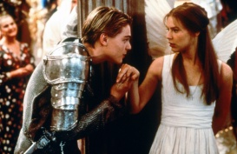**Read the text and answer the questions that follow.**

William Shakespeare

William Shakespeare was born in Stratford on April 23rd, 1564. His father, John Shakespeare, was an important man in the town – William didn’t come from a poor family.

When he was eighteen, William married Anne Hathaway in Stratford but he didn’t want to stay there. He wanted to be an actor and the best theatres were in London. So, in 1587, William went to London, where he worked as an actor in a theatre called The Rose.

He began to write plays for the actors. He wrote **Romeo and Juliet**, **Julius Caesar, Richard II, Antony and Cleopatra** ,Macbeth and many more. Everyone liked his plays, and he became famous.

When James I became king in 1603, Shakespeare worked for him, and performed his plays for the King and his friends. He also worked at the famous Globe Theatre. This play presented his last play, Henry VIII. There was a gun in this play, and the fire from the gun burned the theatre down.

In 1610, Shakespeare went back to Stratford. He wanted to live there with his family, but he died on April 23rd, 1610. He was only forty-six years old.

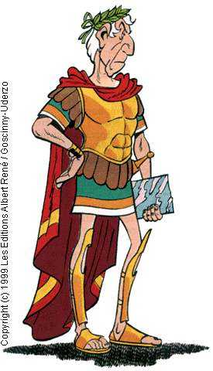

1. How old was Shakespeare when he got married?

__________________________________________

1. What was his wife’s name?

__________________________________________

1. Why did Shakespeare go to London?

__________________________________________

1. What was the name of the first theatre he worked in?

__________________________________________

1. What was he famous for?

__________________________________________

**B.Fill in the table with what happened in Shakespeare’s life in these years**.

|  |  |
| --- | --- |
| 1564 |  |
| 1582 |  |
| 1587 |  |
| 1603 |  |
| 1610 |  |

GRAMMAR TIME

1. 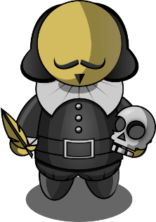**COMPLETE THE SENTENCES WITH THE CORRECT FORM OF THE VERBS IN THE BOX. USE THE PRESENT SIMPLE AND THE PAST SIMPLE.**

be ⬥ die ⬥ visit ⬥ write ⬥ love ⬥ become ⬥ work ⬥ move ⬥ not live ⬥ be

Example: William Shakespeare __*was*__ born in Stratford on the 23th April 1564.

1. He __________________ on the same day, 23th April, fifty-two years later.
2. Over 500,000 tourists ___________________ Stratford every year.
3. Shakespeare _____________________ in Stratford all his life. He __________________ to London in 1585.
4. In London, he ____________________ as an actor and he ____________________ plays.
5. People __________________ Shakespeare’s plays and he _________________ a rich man.
6. Shakespeare’s plays ______________________ still very popular today.
7. 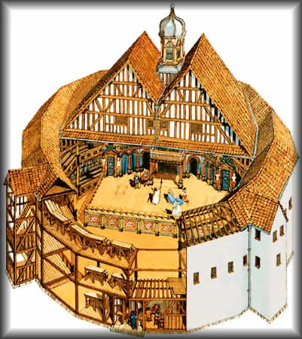**COMPLETE THE TEXT WITH THE CORRECT FORM OF PAST SIMPLE.**

The first Globe Theatre, Shakespeare’s theatre, __*burned*__ (*burn*) to the ground in 1613. Actors were performing the play **Henry VII** at the time. They were using a real cannon on the stage when suddenly a fire

**1.** _____________________ (*start*) in the roof. The fire

**2.** ___________________ (*move*) quickly through the wooden building and **3.**___________________ (*destroy*) it completely. A year later they

**4.** _________________ (*open*) the Globe theatre again.

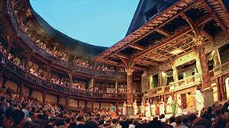 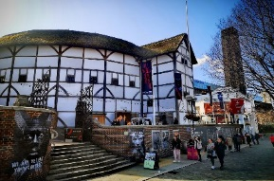

**Did you know this?**

The theatres in Shakespeare’s time were large open-air circles with a stage at one side. Just think of an open-air concert in our time and you get an idea of what was going on in the theatres in Shakespeare’s time 400 years ago. And of course Shakespeare, as a clever entertainer, used music. His plays were full of songs. Unfortunately, the original pieces of music are lost. The seats in the theatres in Shakespeare’s time were only for the rich people. There were even seats for them on the stage. But there were no seats in front of the stage. So the ordinary theatregoers often had a hard time standing for two, three or more hours to see the play. They were called “groundlings”. They usually enjoyed the plays but when they got bored they would boo at the actor and shout out loud comments or even throw things and eggs and rotten food unto the stage.

 Watch the story/video by the british council

TWELFTH NIGHT,by W.Shakespeare

<https://learnenglishkids.britishcouncil.org/short-stories/twelfth-night?_ga=2.14207797.366937953.15>

Are the sentences True or false? Circle **True** or **False** for these sentences.

a. Viola and her twin brother Sebastian are shipwrecked. True False

b. Viola disguises herself as a boy because she needs a job. True False

c. Duke Orsino sends messages to Lady Olivia because he hates her. True False

d. Viola is happy because she loves Duke Orsino. True False

e. Viola is worried because Lady Olivia starts to fall in love with Cesario. True False

f. Viola doesn’t tell the truth because of her brother. True False

g. Sebastian is really dead. True False

h. Sebastian doesn’t understand but he agrees to marry Lady Olivia. True False

i. Duke Orsino is happy when Olivia calls Viola her husband. True False

j. Lady Olivia marries Sebastian and Viola marries Duke Orsino. True False

Thank you my students.

Check: 1.T 2.T 3.F 4.F 5.T 6. F 7. F 8.T 9.F 10.T